You can use Axios.cancel instead of using Debounce

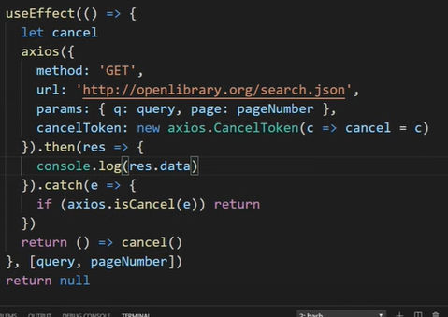

How React works under the hood

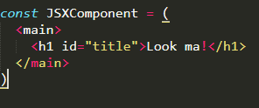

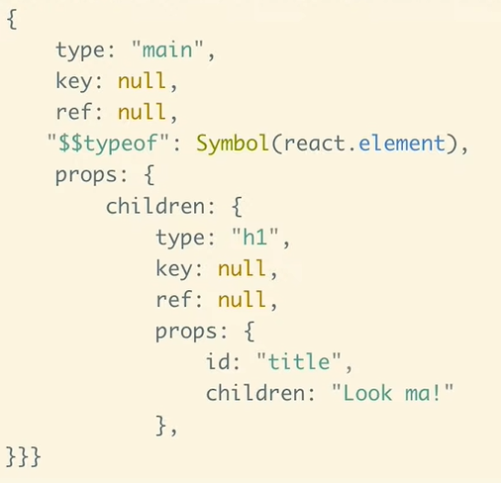This would be used if there would not exist JSX.  
  
  
Symbol generates unique hex.